Predicting Income with Social Data
Linear Regression Extension (PSID 2017) — Practice + Solution Project
Problem Statement
The Panel Study of Income Dynamics (PSID) contains rich social and demographic variables. A social-policy research team needs a transparent, interpretable model that quantifies how education, age and gender relate to labor income and produces narratives adaptable for technical supervisors, executives and non-specialist audiences. Zero-inflation, coded missings (99/999) and mixed audience literacy make both the statistical workflow and communication design non-trivial.
Solution Strategy
1. Inspect structure & distributions. 2. Filter to working age (18–75), plausible education (5–25 yrs) and positive labor income. 3. 60/40 train-test split. 4. Fit simple LM then multiple LM (+ age + gender). 5. Assess fit (R², residuals, LOESS). 6. Interpret coefficients ceteris paribus and prepare audience-adapted messaging. 7. Monte-Carlo sensitivity simulation.
Solution
After cleaning, ~1 600 earners remain. Simple-model R² ≈ 0.03; multiple-model R² ≈ 0.13. Education coefficient (multiple) ≈ +$1 400 per additional year of schooling (holding age & gender fixed). Age strongly positive; female earners show a negative differential. Large residual variance remains (occupation, hours, region omitted).
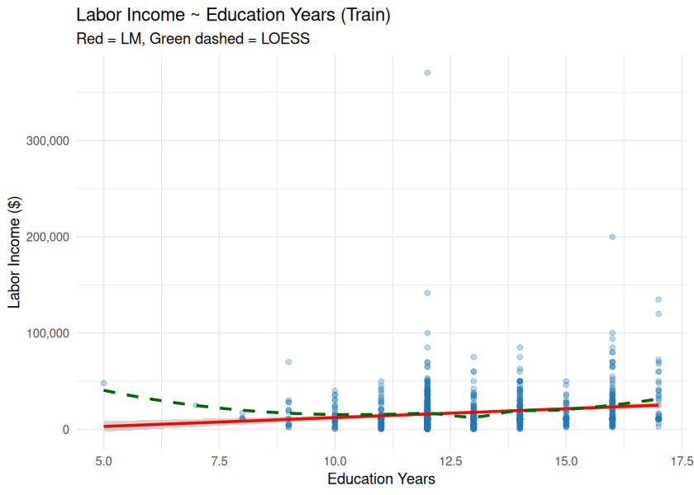
Figure: Labor income vs education years — OLS (red) & LOESS (green dashed)
Key Takeaways
• Always inspect coded missings and zero-inflation before modelling survey income data.
• Multiple regression raises explanatory power and enables ceteris-paribus statements about education returns.
• Coefficient narratives must be rewritten for different audiences (data-literacy & subject-knowledge checklist).
• Simulation confirms the education coefficient stays positive under reasonable sample/noise perturbations.
• Deliverables: Practice Skeleton + Solution notebooks, flowchart, cheat sheet, audience-adapted memo.

